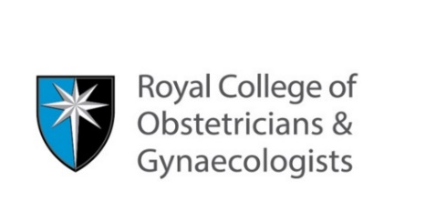

COVID 19 Training Disruption Notification Form
The School appreciates that trainees may have experienced an alteration to their clinical experience due to COVID 19 and that future educational plans will need to take these changes into account. This form is to record how your training activity has been affected and will be reviewed at ARCP by the panel.

Trainee details:
Full name:
Specialty:
GMC Number:
Grade:
email address:

Educational Supervisor details:
Educational Supervisor name:
Educational Supervisor email address:

Reason for disruption to training:

Please select from the following options:

Category | Tick any that apply
- Cancellation of teaching sessions
- Cancellation of examinations
- Change in clinical placement
- Suspension of additional role (eg Flexible Portfolio, Chief Registrar etc)
- Return from Research activity (ACF/ACL/OOPR)
- Sick leave*
- Self-isolation*
- Carers leave*
Expected Duration (if known)
Please provide details of the disruption:
Categories with an asterisk (6,7 & 8) require you to inform your employer

Any other relevant information:

Please upload the completed form to the ‘Other Evidence’ section of your ePortfolio

